# Media Analysis - Will ChatGPT and AI have an impact on Saudi workforce productivity

## Short Summary

The article explores ChatGPT's role in enhancing Saudi Arabia's workforce productivity by automating tasks, emphasizing efficiency gains but acknowledging job displacement concerns and advocating for continuous learning to adapt.

## Summary

1. ChatGPT and other AI platforms are reshaping Saudi Arabia's workforce by boosting productivity through automation of mundane tasks, freeing employees to focus on strategic activities.  
2. The implementation of AI technologies in Saudi Arabia will require a holistic approach that outlines clear objectives, benefits, and potential risks.  
3. AI can positively impact recruitment, training, upskilling, reskilling, talent collaboration, and knowledge management within the Kingdom's workforce, as per Raymond Khoury, senior partner at Arthur D. Little.  
4. ChatGPT will likely replace workers involved in repetitive tasks, necessitating retraining or upskilling to remain marketable in an increasingly AI-enabled digital world.  
5. The automation of tasks by AI poses both opportunities and challenges for Saudi Arabia's workforce and organizations, with potential job losses but also new career prospects.  
6. Khoury highlights that ChatGPT has identified specific jobs likely to be automated in the future, emphasizing the need for adaptability and strategic planning among workers and organizations.  
7. AI implementation requires solid leadership, a futuristic vision, agility in making timely changes, and an optimistic environment fostering continuous learning and improvement.

## Question 1:

How do the media in this article frame the public discussion about ChatGPT? Are there certain **metaphors** that keep cropping up?

The media frames the public discussion about ChatGPT positively, emphasizing its potential to revolutionize sectors through increased productivity and innovation. Key metaphors that keep cropping up include 'revolution,' 'transformation,' 'opportunity,' and 'upskilling.' These metaphors highlight ChatGPT's role as a catalyst for significant change, enabling workers to transition from mundane tasks to more strategic roles in an AI-driven world.

## Question 2:

Which role does or might the Arabic World play in the development of Artificial Intelligence? Answer with 'Not mentioned' if not applicable.

Not applicable

## Question 3:

Which use cases of Artificial Intelligence are helpful for the Arabic world based on this article?

The use cases of Artificial Intelligence helpful for the Arabic world, as highlighted by Raymond Khoury in this article, include tailor-made training programs with ChatGPT, automation of mundane tasks across multiple sectors leading to increased efficiency and strategic focus, and leveraging AI for more personalized services like chronic disease treatment, optimized logistics, improved exploration accuracy, fraud detection, business setup decisions at transit stations, and retail growth opportunities.

## Question 4:

What is the final message of the article that the author wants to convey? Keep your answer short and precise!

The author concludes by stressing the importance of a strategic approach that considers both positive impacts like boosting productivity and potential negative effects job replacement , emphasizing the need for understanding operational bottlenecks, defining objectives, and fostering continuous learning to ensure successful AI integration in Saudi Arabia's workforce.

## Sentiment

The sentiment is <3>

The article presents a balanced perspective on ChatGPT and Artificial Intelligence's impact on Saudi Arabia's workforce. It highlights both the opportunities AI brings, such as increased productivity and new training programs, and the concerns about job displacement due to automation. The author, Raymond Khoury, reassures the fear of losing jobs with AI by emphasizing the need for a strong AI culture and tailor-made training programs. He acknowledges that while AI can replace mundane tasks, it also offers chances for upskilling and reskilling to stay marketable in an evolving digital world. The overall sentiment is mixed, indicating that AI will bring significant changes but also requires proactive measures to mitigate potential negative effects.

## Entities

Raymond Khoury, Nour El, Flip Khoury, Foster Collaboration Communication Team, Embed Ai Operation Saudi Company Employee Require Holistic Approach Clearly Define Strategic Objective Advantage Disadvantage Kaspersky Survey Support, Regard Energy Sector Innovative Technology, Arthur, Https Medium Arab News Country, Cairo Chatgpt Artificial Intelligence Platform Create Wave Change Global Workforce Turn Useful Tool Saudi Arabia Personnel Boost Economic Development Ai Raise Concern, Chatgpt Ai, Khoury, Task Automate, Arthur Littlehe Add Ai

## Topic Clusters

### Cluster: AI in Media

ChatGPT, Artificial Intelligence

### Cluster: Societal Effects of AI

Ethical Concerns, Job Displacement, Misinformation Spread

### Cluster: Technological Advancements

AI Integration, AI Capabilities

### Cluster: Public Perception and Trust

Media Coverage on ChatGPT, Public Reactions

## Word Clouds

### Wordcloud of content

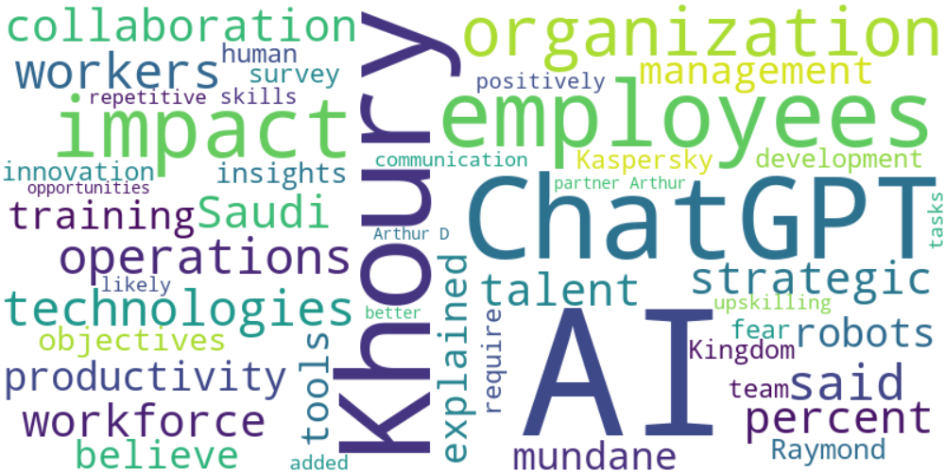

Top 10 words:

- AI: 34  
- Khoury: 15  
- ChatGPT: 12  
- employees: 11  
- impact: 9  
- technologies: 6  
- operations: 6  
- said: 6  
- workers: 6  
- Saudi: 5

### Wordcloud of summary



Top 10 words:

- AI: 6  
- ChatGPT: 3  
- Saudi: 3  
- Arabia: 3  
- workforce: 3  
- tasks: 3